**Integrated Terminal**

In Visual Studio Code, you can open an integrated terminal, initially starting at the root of your workspace. This can be very convenient as you don't have to switch windows or alter the state of an existing terminal to perform a quick command line task.

To open the terminal:

* Use the Ctrl+` keyboard shortcut with the backtick character.
* Use the **View** > **Terminal** menu command.
* From the **Command Palette** (Ctrl+Shift+P), use the **View:Toggle Integrated Terminal** command.

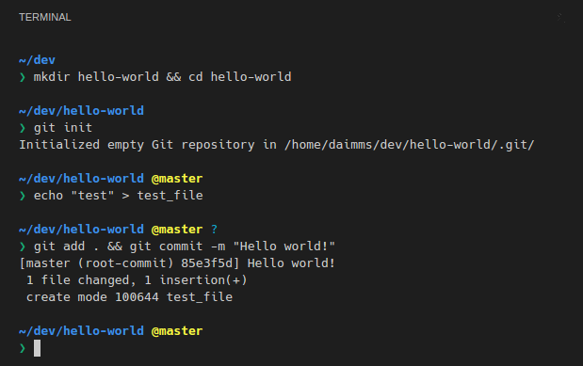

**Note:** You can still open an external shell with the Ctrl+Shift+C keyboard shortcut if you prefer to work outside VS Code.

**Managing Multiple Terminals**

You can create multiple terminals open to different locations and easily navigate between them. Terminal instances can be added by hitting the plus icon on the top-right of the **TERMINAL** panel or by triggering the Ctrl+Shift+` command. This creates another entry in the dropdown list that can be used to switch between them.

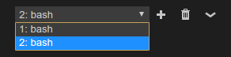

Remove terminal instances by pressing the trash can button.

**Tip:** If you use multiple terminals extensively, you can add key bindings for the focusNext, focusPrevious and kill commands outlined in the [Key Bindings section](https://code.visualstudio.com/docs/editor/integrated-terminal#_terminal-key-bindings) to allow navigation between them using only the keyboard.

**Terminal Splitting**

You can also split the terminal by triggering the Ctrl+\ command or via the right click context menu.

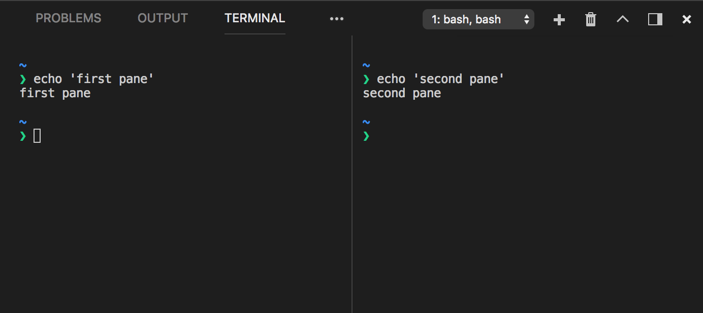

When focusing a split terminal pane, you can move focus and resize using one of the following commands:

| **Key** | **Command** |
| --- | --- |
| Alt+Left | Focus Previous Pane |
| Alt+Right | Focus Next Pane |
| unassigned | Resize Pane Left |
| unassigned | Resize Pane Right |
| unassigned | Resize Pane Up |
| unassigned | Resize Pane Down |

**Configuration**

The shell used defaults to $SHELL on Linux and macOS, PowerShell on Windows 10 and cmd.exe on earlier versions of Windows. These can be overridden manually by setting terminal.integrated.shell.* in [settings](https://code.visualstudio.com/docs/getstarted/settings). Arguments can be passed to the terminal shell using the terminal.integrated.shellArgs.* settings.

**Windows**

Correctly configuring your shell on Windows is a matter of locating the right executable and updating the setting. Below are a list of common shell executables and their default locations:

// Command Prompt

"terminal.integrated.shell.windows": "C:\\Windows\\System32\\cmd.exe"

// PowerShell

"terminal.integrated.shell.windows": "C:\\Windows\\System32\\WindowsPowerShell\\v1.0\\powershell.exe"

// Git Bash

"terminal.integrated.shell.windows": "C:\\Program Files\\Git\\bin\\bash.exe"

// Bash on Ubuntu (on Windows)

"terminal.integrated.shell.windows": "C:\\Windows\\System32\\bash.exe"

There is also the convenience command Select Default Shell that can be accessed through the command palette which can detect and set this for you.

**Note:** To be used as an integrated terminal, the shell executable must be a console application so that stdin/stdout/stderr can be redirected.

**Tip:** The integrated terminal shell is running with the permissions of VS Code. If you need to run a shell command with elevated (administrator) or different permissions, you can use platform utilities such as runas.exe within a terminal.

**Shell arguments**

You can pass arguments to the shell when it is launched.

For example, to enable running bash as a login shell (which runs .bash_profile), pass in the -l argument (with double quotes):

// Linux

"terminal.integrated.shellArgs.linux": ["-l"]

**Terminal Display Settings**

You can customize the integrated terminal font and line height with the following settings:

* terminal.integrated.fontFamily
* terminal.integrated.fontSize
* terminal.integrated.fontWeight
* terminal.integrated.fontWeightBold
* terminal.integrated.lineHeight

**Terminal Key Bindings**

The **View: Toggle Integrated Terminal** command is bound to Ctrl+` to quickly toggle the integrated terminal panel in and out of view.

Below are the keyboard shortcuts to quickly navigate within the integrated terminal:

| **Key** | **Command** |
| --- | --- |
| Ctrl+` | Show integrated terminal |
| Ctrl+Shift+` | Create new terminal |
| Ctrl+Alt+PageUp | Scroll up |
| Ctrl+Alt+PageDown | Scroll down |
| Shift+PageUp | Scroll page up |
| Shift+PageDown | Scroll page down |
| Ctrl+Home | Scroll to top |
| Ctrl+End | Scroll to bottom |
| Ctrl+K | Clear the terminal |

Other terminal commands are available and can be bound to your preferred keyboard shortcuts.

They are:

* workbench.action.terminal.focus: Focus the terminal. This is like toggle but focuses the terminal instead of hiding it, if it is visible.
* workbench.action.terminal.focusNext: Focuses the next terminal instance.
* workbench.action.terminal.focusPrevious: Focuses the previous terminal instance.
* workbench.action.terminal.focusAtIndexN: Focuses the terminal at index N (N=1-9)
* workbench.action.terminal.kill: Remove the current terminal instance.
* workbench.action.terminal.runSelectedText: Run the selected text in the terminal instance.
* workbench.action.terminal.runActiveFile: Run the active file in the terminal instance.

**Copy & Paste**

The keybindings for copy and paste follow platform standards:

* Linux: Ctrl+Shift+C and Ctrl+Shift+V
* macOS: Cmd+C and Cmd+V
* Windows: Ctrl+C and Ctrl+V

**Right click behavior**

The right click behavior differs based on the platform:

* Linux: Show the context menu.
* macOS: Select the word under the cursor and show the context menu.
* Windows: Copy and drop selection if there is a selection, otherwise paste.

This can be configured using the terminal.integrated.rightClickBehavior setting.

**Forcing key bindings to pass through the terminal**

While focus is in the integrated terminal, many key bindings will not work as the keystrokes are passed to and consumed by the terminal itself. The terminal.integrated.commandsToSkipShell setting can be used to get around this. It contains an array of command names whose key bindings will skip processing by the shell and instead be processed by the VS Code key binding system. By default, this includes all terminal key bindings in addition to a select few commonly used key bindings.

**Find**

The Integrated Terminal has basic find functionality which can be triggered with Ctrl+F.

If you want Ctrl+F to go to the shell instead of launching the Find widget on Linux and Windows, you will need to remove the keybinding like so:

// Windows/Linux

{ "key": "ctrl+f", "command": "-workbench.action.terminal.focusFindWidget",

"when": "terminalFocus" },

// macOS

{ "key": "cmd+f", "command": "-workbench.action.terminal.focusFindWidget",

"when": "terminalFocus" },

**Run Selected Text**

To use the runSelectedText command, select text in an editor and run the command **Terminal: Run Selected Text in Active Terminal** via the **Command Palette** (Ctrl+Shift+P):

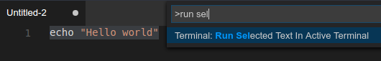

The terminal will attempt to run the selected text.

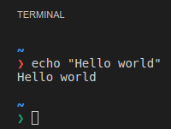

If no text is selected in the active editor, the line that the cursor is on is run in the terminal.

**Send text from a keybinding**

The workbench.action.terminal.sendSequence command can be used to send a specific sequence of text to the terminal, including escape sequences. This enables things like sending arrow keys, enter, cursor moves, etc. The example below shows the sorts of things you can achieve with this feature, it jumps over the word to the left of the cursor (ctrl+left arrow) and presses backspace:

{

"key": "ctrl+u",

"command": "workbench.action.terminal.sendSequence",

"args": { "text": "\u001b[1;5D\u007f" }

}

Note that the command only works with the \u0000 format for using characters via their character code (not \x00). You can read more about these hex code and the sequences terminals work with on the following resources:

* [XTerm Control Sequences](http://invisible-island.net/xterm/ctlseqs/ctlseqs.html)
* [List of C0 and C1 control codes](https://github.com/xtermjs/xterm.js/blob/0e45909c7e79c83452493d2cd46d99c0a0bb585f/src/common/data/EscapeSequences.ts)

**Rename terminal sessions**

Integrated Terminal sessions can now be renamed using the **Terminal: Rename** (workbench.action.terminal.rename) command. The new name will be displayed in the terminal selection drop-down.

**Open at a specific folder**

By default, the terminal will open at the folder that is opened in the Explorer. The terminal.integrated.cwd setting allows specifying a custom path to open instead:

{

"terminal.integrated.cwd": "/home/user"

}

There are also extensions available that give more options such as [Terminal Here](https://marketplace.visualstudio.com/items?itemName=Tyriar.vscode-terminal-here).

**Changing how the terminal is rendered**

By default, the integrated terminal will render using multiple <canvas> elements which is better tuned than the DOM for rendering interactive text that changes often. However, Electron/Chromium are slower rendering to canvas on some environment and so VS Code also provides a fallback DOM-renderer experience. VS Code will try to detect slow performance and give you the option to change via a notification. You can also change the rendering directly by setting terminal.integrated.rendererType in your user or workspace [settings](https://code.visualstudio.com/docs/getstarted/settings).

{

"terminal.integrated.rendererType": "dom"

}

Something else that might improve performance is to ignore Chromium's GPU blacklist by launching VS Code with code --ignore-gpu-blacklist.

**Next Steps**

The basics of the terminal have been covered in this document, read on to find out more about:

* [Tasks](https://code.visualstudio.com/docs/editor/tasks) - Tasks let you integrate with external tools and leverage the terminal heavily.
* [Mastering VS Code's Terminal](https://www.growingwiththeweb.com/2017/03/mastering-vscodes-terminal.html) - An external blog with plenty of power user tips for the terminal.
* Explore the rest of the terminal commands by browsing your keybindings.json file within VS Code.

**Common Questions**

**Why is VS Code shortcut X not working when the terminal has focus?**

Currently the terminal consumes many key bindings, preventing Visual Studio Code from reacting to them. Some examples are F1 to open the **Command Palette** and Ctrl+P for **Quick Open** on Linux and Windows. This is necessary as various terminal programs and/or shells may respond to these key bindings themselves. There are plans to explore a blacklist that would prevent certain key bindings from being handled by the terminal (see [#7269](https://github.com/Microsoft/vscode/issues/7269)).

**Integrated terminal exited with code 1 on Windows 10**

This can happen if you run VS Code in compatibility mode which may be turned on automatically if you have upgraded Windows. You can change this by right-clicking the executable and selecting properties, then uncheck "Run this program in compatibility mode" in the compatibility tab.

**Can I use Cmder's shell with the terminal on Windows?**

Yes, to use the [Cmder](http://cmder.net/) shell in VS Code, you need to create a vscode.bat file in your cmder path with the following contents (edit the cmder path if necessary):

@echo off

SET CurrentWorkingDirectory=%CD%

SET CMDER_ROOT=C:\cmder

CALL "%CMDER_ROOT%\vendor\init.bat"

CD /D %CurrentWorkingDirectory%

then in your VS Code user settings, add the following to your settings.json file:

"terminal.integrated.shell.windows": "C:\\WINDOWS\\System32\\cmd.exe",

"terminal.integrated.shellArgs.windows": ["/K", "C:\\cmder\\vscode.bat"]

**Can I use Cygwin's shell with the terminal on Windows?**

Yes, to use the [Cygwin](http://cygwin.com/) shell, you will first need to install the chere package and then add the following settings to your settings.json file:

"terminal.integrated.shell.windows": "C:\\Cygwin\\bin\\bash.exe",

"terminal.integrated.shellArgs.windows": ["/bin/xhere", "/bin/bash"]

**Powershell on macOS is complaining about a "-l" argument, how do I fix it?**

When configuring the integrated terminal to use Powershell on macOS you may hit [this error](https://github.com/Microsoft/vscode/issues/33022) complaining about a "-l" argument. To fix this you will need to override the shell args setting as it defaults to ["-l"] to run login shells by default (for bash/zsh/etc.).

"terminal.integrated.shellArgs.osx": []

**How can I change my default Windows terminal back to PowerShell?**

If you want to put the default Integrated Terminal shell back to the default (PowerShell on Windows), you can remove the shell override from your User [Settings](https://code.visualstudio.com/docs/getstarted/settings) (Ctrl+,).

For example, if you have set your default terminal to bash, you will find terminal.integrated.shell.windows in your settings.json pointing to your bash location.

"terminal.integrated.shell.windows": "C:\\WINDOWS\\System32\\bash.exe",

Remove the entry to use the built-in VS Code default or set it to another shell executable path.

**Why is the terminal not working when running the 32-bit Windows client on 64-bit Windows?**

The easy fix for this is to use the 64-bit version. If you must use the 32-bit version you need to use the sysnative path when configuring your paths instead of System32:

"terminal.integrated.shell.windows": "C:\\WINDOWS\\sysnative\\cmd.exe",

**Why is Cmd+k/Ctrl+k not clearing the terminal?**

Normally Cmd+k/Ctrl+k clears the terminal on macOS/Windows, but this can stop working when chord keybindings are added either by the user or extensions. The Cmd+k/Ctrl+k keybindings rely on the VS Code keybinding priority system which defines which keybinding is active at any given time (user > extension > default). In order to fix this, you need to redefine your user keybinding which will have priority, preferably at the bottom of your user keybindings.json file:

macOS:

{ "key": "cmd+k", "command": "workbench.action.terminal.clear",

"when": "terminalFocus" },

Windows:

{ "key": "ctrl+k", "command": "workbench.action.terminal.clear",

"when": "terminalFocus" },

**Why is nvm complaining about a prefix option when the Integrated Terminal is launched?**

nvm (Node Version Manager) users often see this error for the first time inside VS Code's Integrated Terminal:

nvm is not compatible with the npm config "prefix" option: currently set to "/usr/local"

Run `npm config delete prefix` or `nvm use --delete-prefix v8.9.1 --silent` to unset it

This is mostly a macOS problem and does not happen in external terminals. The typical reasons for this are the following:

* npm was globally installed using another instance of node which is somewhere in your path (such as /usr/local/bin/npm).
* In order to get the development tools on the $PATH, VS Code will launch a bash login shell on start up. This means that your ~/.bash_profile has already run and when an Integrated Terminal launches, it will run **another** login shell, reordering the $PATH potentially in unexpected ways.

To resolve this issue, you need to track down where the old npm is installed and remove both it and its out of date node_modules. You can do this by finding the nvm initialization script and running which npm before it runs, which should print the path when you launch a new terminal.

Once you have the path to npm, you can find the old node_modules by resolving the symlink by running a command something like this:

ls -la /usr/local/bin | grep npm

This will give you the resolved path at the end:

... npm -> ../lib/node_modules/npm/bin/npm-cli.js

From there, removing the files and relaunching VS Code should fix the issue:

rm -R /usr/local/bin/npm /usr/local/lib/node_modules/npm/bin/npm-cli.js

**Can I use Powerline fonts in the Integrated Terminal?**

Yes, you can specify [Powerline](https://powerline.readthedocs.io) fonts with the terminal.integrated.fontFamily [setting](https://code.visualstudio.com/docs/getstarted/settings).

"terminal.integrated.fontFamily": "Meslo LG M DZ for Powerline"

Note that you want to specify the font family, not an individual font like **Meslo LG M DZ Regular for Powerline** where **Regular** is the specific font name.